**EXPERIMENT 11**

**Q1**

**HTML:**

<html>

<body>

<form action="p11q1.php" method="get">

Select Year: <br>

<select name="year" id="year">

<option value="1st">1st</option>

<option value="2nd">2nd</option>

<option value="3rd">3rd</option>

<option value="4th">4th</option>

</select><br><br>

Select Dept: <br>

<select name="dept" id="dept" multiple="multiple" size="5">

<option value="Computer">Computer</option>

<option value="Civil">Civil</option>

<option value="Electronics">Electronics</option>

<option value="Mechanical">Mechanical</option>

<option value="Automobile">Automobile</option>

</select>

<input type="hidden" name="hidden" value="This is hidden"><br><br>

<input type="submit" value="submit">

<input type="reset" value="reset">

</form>

</body>

</html>

**PHP**:

<?php

echo "20438 UMME ATIYA<br><hr>";

echo "Your Year: ";

print_r($_GET['year']);

echo "<br>Your department: ";

print_r($_GET['dept']);

echo "<br>Your Hidden: ";

print_r($_GET['hidden']);

?>

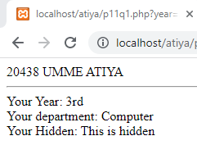 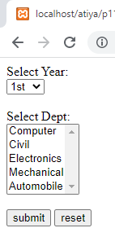

**EXPERIMENT 12**

Q1

HTML:

<html>

<body>

20438 UMME ATIYA<br><hr>

<form action="p12q1.php" method="get">

NAME: <input type="text" name="name"/><br><br>

AGE: <input type="text" name="age"/><br><br>

D.O.B: <input type="text" name="dob"/><br><br>

EMAIL: <input type="text" name="email"/><br><br>

PASS: <input type="password" name="pass"/><br><br>

<input type="submit" value="submit">

<input type="reset" value="reset">

</form>

</body>

</html>

PHP:

<?php

echo "20438 UMME ATIYA<br><hr>";

$name=$_GET["name"];

$age=$_GET["age"];

$dob=$_GET["dob"];

$email=$_GET["email"];

$pass=$_GET["pass"];

$n="/^[A-Za-z]{1,}$/";

$a="/^[0-9]{1,}$/";

$d="/^([0][1-9]|[12][1-9]|[3][01])[-\/.](0[1-9]|[1][012])[-\/.](19|20)\d\d$/";

$e="/^[a-bA-B]|[._a-zA-Z0-9]{0,}@[.a-zA-Z]{1,}(.com)$/";

$p="/^([0-9a-zA-Z_.!]{8,}$)/";

if(preg_match($n,$name)){

echo "correct<br>";

}

else{

echo "not correct<br>";

}

if(preg_match($a,$age)){

echo "correct<br>";

}

else{

echo "not correct<br>";

}

if(preg_match($d,$dob)){

echo "correct<br>";

}

else{

echo "not correct<br>";

}

if(preg_match($e,$email)){

echo "correct<br>";

}

else{

echo "not correct<br>";

}

if(preg_match($p,$pass)){

echo "correct<br>";

}

else{

echo "not correct<br>";

}

// echo($name.$age.$dob.$email.$pass);

?>

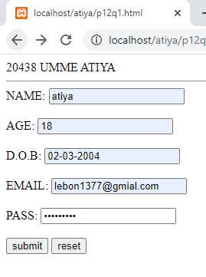 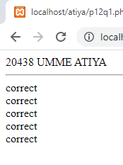

Q2

HTML:

<html>

<body>

<h4>IP Address</h4>

<form action="p12q2.php" method="POST">

<label>IP:</label>

<input type="text" name="text1" size="30" /><br /><br />

<input type="submit" name="submit1" value="Submit Details" />

&nbsp&nbsp&nbsp <input type="reset" name="reset1" value="Reset Details" />

</form>

</body>

</html>

PHP:

<?php

echo "20438 UMME ATIYA<br><hr>";

$ip = $_POST["text1"];

$regex_ip = "/^\d{1,3}\.\d{1,3}\.\d{1,3}\.\d{1,3}$/";

if (preg_match($regex_ip, $ip))

echo "You have Eneterd Correct IP Address";

else

echo "<br>Invalid IP Address";

?>

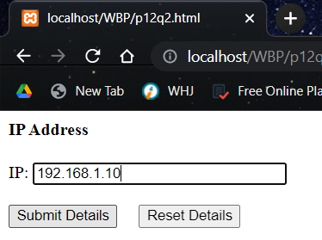 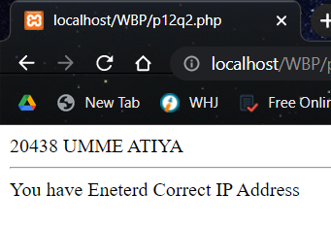

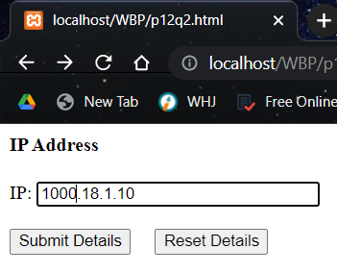 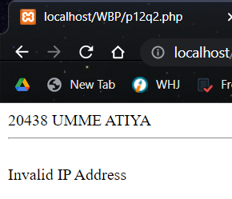

Q3

HTML:

<html>

<body>

<h4>Company Email ID</h4>

<form action="p12q3.php" method="POST">

<label>Company Email ID:</label>

<input type="text" name="text1" size="30" /><br /><br />

<input type="submit" name="submit1" value="Submit Details" />

&nbsp&nbsp&nbsp <input type="reset" name="reset1" value="Reset Details" />

</form>

</body>

</html>

PHP:

<?php

echo "20438 UMME ATIYA<br><hr>";

$email = $_POST["text1"];

$regex_email = '/^[_a-z0-9-]+(\.[_a-z0-9-]+)*@[a-z0-9-]+(\.[a-z0-9-]+)*(\.[a-z]{2,3})$/';

if (preg_match($regex_email, $email))

echo "You have Eneterd Correct Emaild ID";

else

echo "<br>Invalid Email ID";

?>

